**BASIC ELECTRONICS**

**Roll Number:22F-BSAI-29**

**Name:Muzzamil Khalid**

**Department : Artificial Intelligence**

**Submitted To : Sir Juniad**

**Lab Assignment:08**

**HALF WAVE RECTIFIER**

OBJECT

To design and simulate a Half Wave Rectifier circuit.

APPARATUS

Function generator, DSO, Power supply, resistor 1K, diode, connecting wires.

THEORY

A rectifier is nothing but a simple diode or group of diodes which converts the Alternating Current (AC) into Direct Current (DC).

A half wave rectifier is a type of rectifier which converts the positive half cycle (positive current) of the input signal into pulsating DC (Direct Current) output signal.

OR

A half wave rectifier is a type of rectifier which allows only half cycle (either positive half cycle or negative half cycle) of the input AC signal while the other half cycle is blocked.

We use only a single diode to construct the half wave rectifier. The half wave rectifier is made up of an AC source, transformer (step-down), diode, and resistor (load). The diode is placed between the transformer and resistor (load).

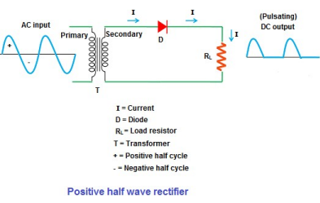

BASIC ELECTRONICS

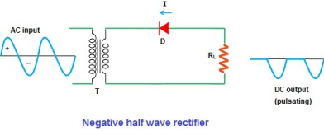

PROCEDURE:

1. Connect the circuit as shown in the circuit diagram.

2. Give the input signal as specified.

3. Switch on the power supply.

4. Note down the value of AC and DC voltages from the CRO

5. Draw the necessary waveforms on the graph sheet.

Assignment:

Design the half-wave rectifier in multisim. Explain the input and output waveforms along with screenshots.

**Circuit diagram.**

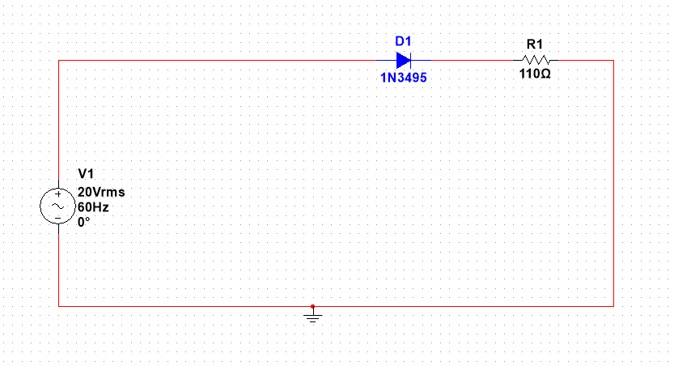

This is an electrical circuit diagram. The circuit includes a voltage source labeled “V1” with specifications of “20Vrms,” “60Hz,” and “0°.” The circuit also contains a diode labeled “D1” with the specification “1N3495” and a resistor labeled “R1” with the specification of “110Ω.” The image shows an electrical circuit diagram drawn on grid paper. All components are connected by red lines representing electrical wires. The diode is depicted in blue color, located at the top center part of the circuit. The resistance value of the resistor is specified as 110Ω. The voltage source has specifications written next to it: 20Vrms, 60Hz, and 0° phase angle.

**Connected with oscilloscope**

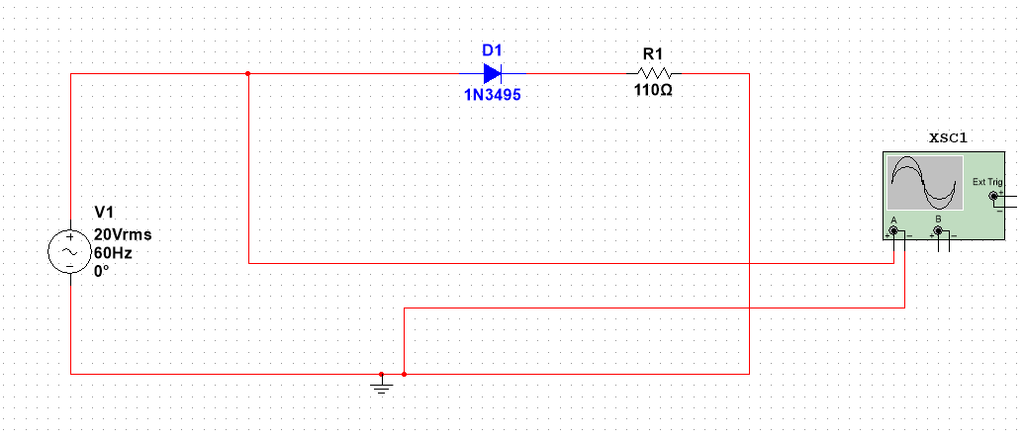

After creating the circuit, I used an oscilloscope to measure the voltage at two points in the circuit. I connected channel A of the oscilloscope before the diode and channel B with the negative terminal. This configuration allows only the AC current to pass through, and the current will be blocked.

**Input Wavelength**

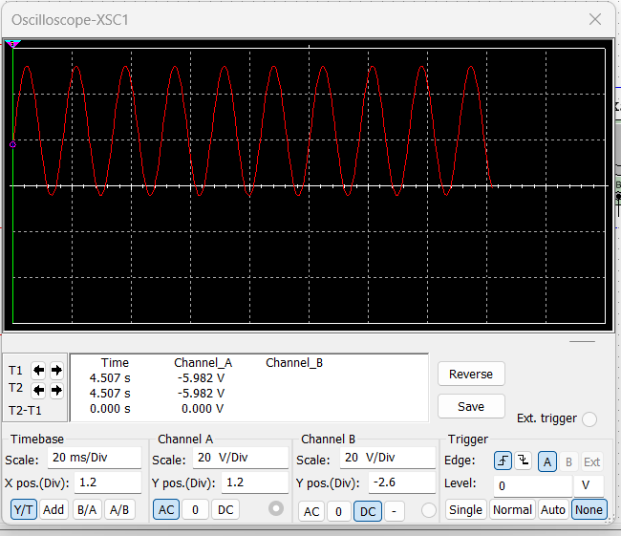

The graph shows the voltage of an **AC (alternating current)** signal over time. The waveform is a sinusoidal wave, indicating the periodic change in current and voltage over time. The amplitude of the waveform represents the maximum voltage of the signal, while the frequency represents the number of cycles per second. The time base setting determines the amount of time each division represents, and thus, how many cycles are visible on the screen. Changing the time base will zoom in or out horizontally on the waveform, altering how many cycles are visible. The channel scale setting determines the amplitude visibility, affecting how the waveform is displayed. Changing the channel scale will zoom in or out vertically, affecting the amplitude visibility. It won’t change the waveform but will affect how it’s displayed.

**Connected with Channel B**

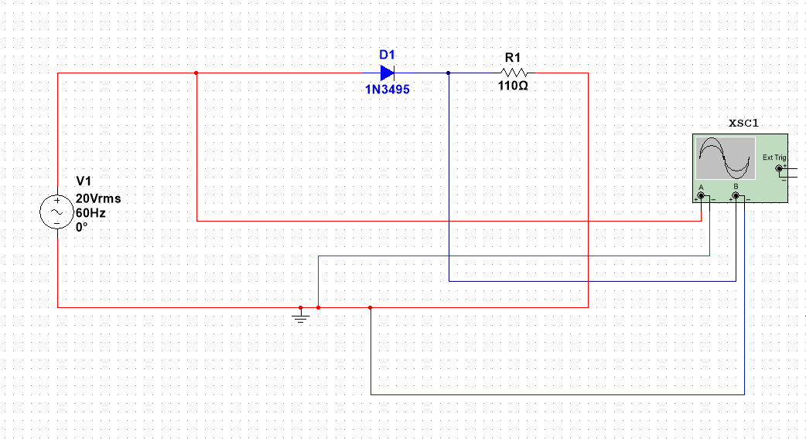

Now we have connected the positive terminal of channel B of the oscilloscope after the diode and the negative terminal to the negative side. I have also colored the connection blue. This setup will allow USto check the output waveform of the circuit through the oscilloscope.

.

**Output Wavelength**

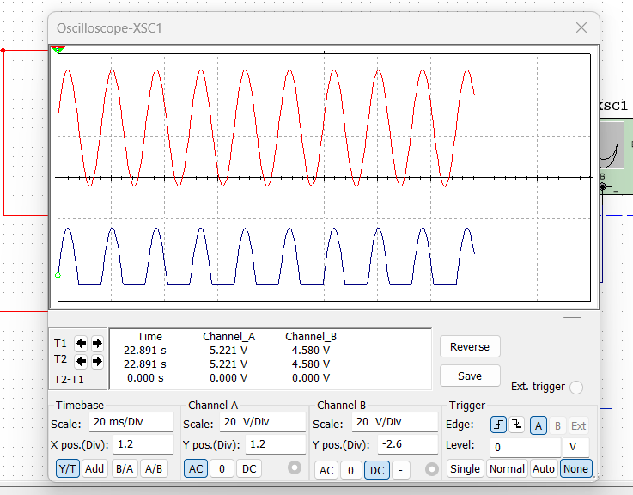

The red wave represents an AC (alternating current) signal, and the blue wave represents a DC (direct current) signal. The AC signal is sinusoidal, meaning it varies in a wave-like manner over time. The DC signal is constant over time.

The horizontal axis of the graph represents time, while the vertical axis represents voltage. The waveform is a sinusoidal wave, indicating the periodic change in current and voltage over time. The amplitude of the waveform represents the maximum voltage of the signal, while the frequency represents the number of cycles per second. The time base setting determines the amount of time each division represents, and thus, how many cycles are visible on the screen. Changing the time base will zoom in or out horizontally on the waveform, altering how many cycles are visible. The channel scale setting determines the amplitude visibility, affecting how the waveform is displayed. Changing the channel scale will zoom in or out vertically, affecting the amplitude visibility. It won’t change the waveform but will affect how it’s displayed.

If we change the value of the time base, it will affect how compressed or stretched the AC waveform appears on the oscilloscope screen. Increasing the time base will show fewer cycles of the waveform on screen, making it appear stretched. Decreasing it will compress and show more cycles. Changing the channel scale will zoom in or out vertically, affecting the amplitude visibility. It won’t change the waveform but will affect how it’s displayed.